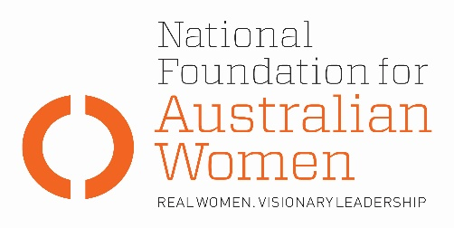

Election 2019 - Newstart allowance

Why is this an issue for women?
- Prior to retirement women face a gender pay gap, broken work histories, have lower superannuation, have a greater incidence of single person households and an increasing incidence of homelessness.

- There are slightly more men than women on NSA, 52% compared to 48%. However, there has been a significant increase in the number of women on NSA since 2012, from 40%, due to increases in the Age Pension qualifying age for women, movement of grandfathered parenting payment recipients onto NSA and the closure and phase out of the wife payment, Widow B Pension, Partners Allowance and Widows Allowance.

- Women who exit the workforce in their 40’s and 50’s to care for grandchildren and/ or ageing parents and then need to re-enter the workforce struggle due to a combination of age and sex discrimination. Anyone retrenched over 55 will spend twice as long on NSA compared to someone less than 55 years old.

- Mature age women are the largest group by age and gender of NSA recipients.

- One of the drivers of poverty for people on the Age Pension is that often older women NSA recipients have been forced to run down any income or assets they may have had. Women’s career development is generally different from men. It is often more complex (for example, conflict between work and family) and is often characterised by different career stages or patterns (for example, intervals away from full time employment to assume care responsibilities).

Election commitments
Full implementation | Partial implementation | No or negative response
The table below sets out how fully parties’ current election commitments address NFAW recommendations:
NFAW RECOMMENDATION
NFAW recommends that the single rate of NSA be increased and payments indexed every 6 months to movements in full time wage levels.
PARTY COMMITMENTS
ALP | LNP | GREENS
A review is proposed and may include indexation arrangements. | No change proposed, however recipients will now receive a $75 energy supplement payment. | Payments to be increased by $75 per week.
NFAW RECOMMENDATION
NFAW recommends there be no increase in the Age Pension eligibility age.
PARTY COMMITMENTS
ALP | LNP | GREENS
No change proposed. | The proposed increase to 70 years has been dropped and will remain at 67. | No change proposed.

OTHER ELECTION COMMITMENTS
Commitment | Party | Comments
 | Choose an item.
 | Choose an item.
 | Choose an item.

