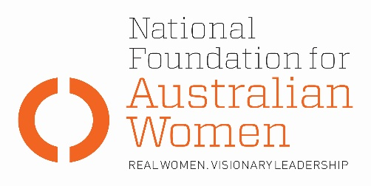

Election 2019 - Family violence leave

Why is this an issue for women?
- Australian women are nearly three times more likely than men to experience violence from an intimate partner (Australian Bureau of Statistics, 4906.0) Over 62% of women experiencing family violence are in paid employment (Australian Bureau of Statistics, 4906.0).

- Over the life course, women who have experienced family violence suffer impediments to career progression and lower superannuation. The compounding economic stress of family violence can keep people in abusive relationships. Conservative estimates place the time-cost of leaving an abusive partner at over 140 hours and the financial costs at upwards of $18,000 (SBS, 13 November 2017). Conversely, job security is a critical facilitator for those experiencing violence to leave violent relationships.

- The Fair Work Commission has updated all industry and occupation awards to include a new clause about family and domestic violence leave to apply from the first full pay period on or after 1 August 2018. The clause entitles all award covered employees (including casuals) to 5 days of unpaid family and domestic violence leave each year. Agreement-covered employees’ award entitlements will have been displaced by whatever is or is not in their agreement.

- The incremental wage payouts associated with 10 days’ paid family and domestic violence leave have been estimated on the basis of current leave patterns to be equivalent to less than one-fiftieth of one percent of existing payrolls (0.02 percent) (Economic Aspects of Domestic Violence Leave, the Australia Institute, p.3).

Election commitments
Full implementation | Partial implementation | No or negative response
The table below sets out how fully parties’ current election commitments address NFAW recommendations:
NFAW RECOMMENDATION
NFAW recommends that the government support a new modern award entitlement of 10 days paid family and domestic violence leave be incorporated into the National Employment Standards.
PARTY COMMITMENTS
ALP | LNP | GREENS
Labor will legislate a minimum entitlement of 10 days of paid leave for people dealing with family violence. (Budget reply) |  | The Greens will also legislate to ensure all workers are entitled to 10 days paid family and domestic violence.

OTHER ELECTION COMMITMENTS
Commitment | Party | Comments
 | Choose an item.
 | Choose an item.
 | Choose an item.

Authorised by Kate Gunn, Sydney.

UN Women National Committee Australia (2017) Taking the first step: Workplace responses to domestic and family violence, Canberra: UN Women

