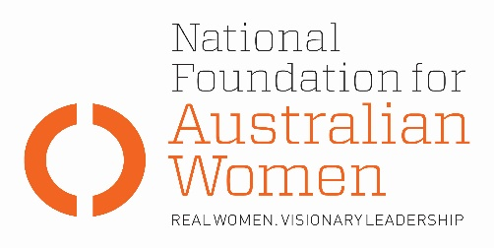

Election 2019 - Penalty rates

Why is this an issue for women?
- Women are disproportionately represented in the retail and hospitality industries; more likely to receive minimum award wages; and more likely to rely on penalty rates to meet household payments (Fair Work Commission, p. 1).

- Following a decision by the Fair Work Commission (FWC), from 1 July 2017, full or part-time retail, fast food, restaurant, hospitality and pharmacy workers without an enterprise bargaining agreement will earn significantly less for working the same hours.
  - Sunday hospitality pay rates will be cut from 175 per cent of their standard wage to 150 per cent. Public holiday rates will fall from 250 per cent to 225 per cent.
  - In retail, Sunday wages will fall from 200 per cent of the standard rate to 150 per cent. On public holidays the penalty rate will fall from 250 per cent to 225 per cent.
  - Those working night shifts will also face pay cuts. (The decision is at the Fair Work Commission.)

Election commitments
Full implementation | Partial implementation | No or negative response
The table below sets out how fully parties’ current election commitments address NFAW recommendations:
NFAW RECOMMENDATION
2017/18 cuts to penalty rates should be restored, and penalty rates should form part of the legislated National Employment Standards under the Fair Work Act.
PARTY COMMITMENTS
ALP | LNP | GREENS
Labor will: legislate to restore the arbitrary cuts to Sunday and public penalty rates in its first 100 days. (Budget reply) |  | The Greens stand for: restoration of penalty rates.

OTHER ELECTION COMMITMENTS
Commitment | Party | Comments
 | Choose an item.
 | Choose an item.
 | Choose an item.

Authorised by Kate Gunn, Sydney.

