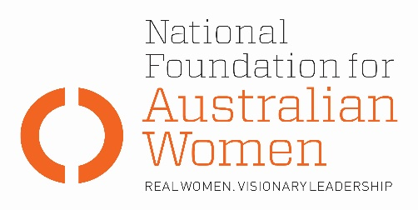

Election 2019 - Career guidance, information and counselling

Why is this an issue for women?
- Women’s career development is generally different from men. It is often more complex (for example, conflict between work and family) and is often characterised by different career stages or patterns (for example, intervals away from full time employment to assume care responsibilities).

- The Australian labour market is highly gender segregated by both industry and occupation, a pattern that has persisted over the past few decades and the level of segregation has increased (WGEA publication Gender Segregation in Australia’s workforce, August 2016). This is despite substantial growth in women’s labour supply, growth in educational attainment, and growth in combining work with raising families.

- Recent research by Economic Security 4 Women demonstrates that there is inadequate attention being paid to supporting women into careers in emergent non-traditional occupations and industries across Australia. This leads to an increasingly segregated labour force with potential to widen the gender pay gap and reduce economic outcomes for women and their families.

- Australia has a National Career Development Strategy. However, it hasn’t been updated since 2013 and makes no reference to gender.

Election commitments
Full implementation | Partial implementation | No or negative response
The table below sets out how fully parties’ current election commitments address NFAW recommendations:
NFAW RECOMMENDATION
The development of a National Career Development Strategy which explicitly addresses gender segregation and explicitly includes the objectives economic independence, social inclusion, and personal fulfilment. Delivery should be by means of an easily accessible multi- channel service delivery arm which includes community partnerships, appropriate quality assurance mechanisms and appropriate tagged funding.
PARTY COMMITMENTS
ALP | LNP | GREENS
No policy proposed. | No policy proposed. | No policy proposed.

OTHER ELECTION COMMITMENTS
Commitment | Party | Comments
 | Choose an item.
 | Choose an item.
 | Choose an item.

