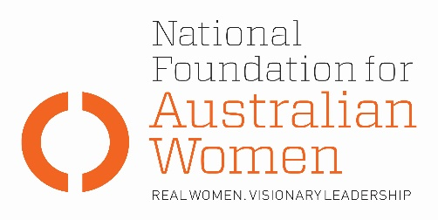

Election 2019 - Casual conversion

Why is this an issue for women?
- Insecure work, incorporating casual work, fixed term contracts, independent contracting and labour hire, has been steadily increasing in Australia. Women are disproportionately impacted by this trend: 26.9 percent of working women are employed on a casual basis, compared to 21.4 percent of men (WGEA’s Gender Equality Scorecard 2016-17, p. 15).

- Modern male-dominated awards covering the construction, manufacturing, electrical and plumbing industries contain a requirement to offer permanent employment to regular and systematic casuals after six months’ employment. This is not replicated in awards covering female-dominated industries.

- The Fair Work Commission (FWC) accepts that the casual loading meant to compensate for the lack of annual and sick leave ‘does not take into account the detriments…includ[ing] attending work while sick, not taking recreational leave because of concerns about whether any absence from work will endanger future employment, the incapacity to properly balance work and attending to personal and caring responsibilities and commitments, changes in working hours without notice, … potential for the sudden loss of what had been regular work without any proper notice or adjustment payment … the lack of a career path, diminished access to training and workplace participation, poorer health and safety outcomes and the inability to obtain loans’ (Fair Work Commission 2017, para 7).

- The National Employment Standards set no minimum to the number of hours a casual may be called in to cover. As a consequence, a casual employee might be expected to pay travel and child care costs to cover one or two hours of work.

- The FWC has proposed a draft model casual conversion clause for the subset of awards lacking any current clause. This specifies a qualifying period of 12 calendar months involving a regular pattern of hours, and enables conversion to be refused on the grounds that it would require a significant adjustment to the casual employee's hours of work to accommodate them in full-time or part-time employment, or that it is known or reasonably foreseeable that the casual employee's position will cease to exist, or that the employee's hours of work will significantly change or be reduced within the next 12 months, or on other reasonable grounds. A 2-hour minimum engagement period for casuals is also proposed (Fair Work Commission 2017).

Election commitments
Full implementation | Partial implementation | No or negative response
The table below sets out how fully parties’ current election commitments address NFAW recommendations:
NFAW RECOMMENDATION
NFAW has recommended that those who have worked on a regular or systematic basis for six consecutive months should have a legislated entitlement to convert to permanent work if they choose. It has also recommended a 3-hour minimum engagement period.
PARTY COMMITMENTS
ALP | LNP | GREENS
Labor will: legislate to ensure
workers can’t be forced to be ‘permanent casuals’ including legislating an objective definition for determining when a worker can be required to work as a casual (Women’s Budget) and the introduction of an objective test for deciding when a worker is a casual.
(16/6/18)
No commitment re conversion or minimum engagement.

OTHER ELECTION COMMITMENTS
Commitment | Party | Comments
 | Choose an item.
 | Choose an item.
 | Choose an item.

Authorised by Kate Gunn, Sydney.

